***Assignment 13 – Pass by address***

Q1)

#include<stdio.h>

#include<string.h>

typedef struct Student{

    int rollNo;

    char name[30];

    int marks[3]; ///marks of two subjects

} Student;

void storeStudent(Student* s1){

    printf("Enter roll no\n");

    scanf("%d", &s1->rollNo);

    printf("Enter name no\n");

    scanf("%s", &s1->name);

    for (int i = 0; i < 3; i++)

    {

        printf("Enter marks for %d\n", i+1);

        scanf("%d", &s1->marks[i]);

    }

}

int main(){

    Student s1, s2;

    storeStudent(&s1);

    storeStudent(&s2);

    printf("\nRollNo-> %d  Name-> %s  Marks1->%d  Marks2->%d\n", s1.rollNo, s1.name, s1.marks[0], s1.marks[1]);

    printf("\nRollNo-> %d  Name-> %s  Marks1->%d  Marks2->%d\n", s2.rollNo, s2.name, s2.marks[0], s2.marks[1]);

    return 0;

}

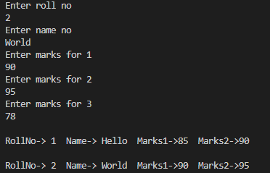

Q2)

#include<stdio.h>

#include<string.h>

typedef struct Employee{

    int id;

    char name[30];

    int salary;

} Employee;

void storeEmps(Employee* emp){

        printf("Enter id\n");

        scanf("%d", &emp->id);

        printf("Enter name\n");

        scanf("%s", emp->name);

        printf("Enter salary\n");

        scanf("%d", &emp->salary);

}

void printEmps(Employee* emp){

        printf("\nid-> %d  Name-> %s  Salary->%d\n", emp->id, emp->name, emp->salary);

}

int main(){

    Employee e1, e2, e3;

    storeEmps(&e1);

    storeEmps(&e2);

    storeEmps(&e3);

    printEmps(&e1);

    printEmps(&e2);

    printEmps(&e3);

    return 0;

}

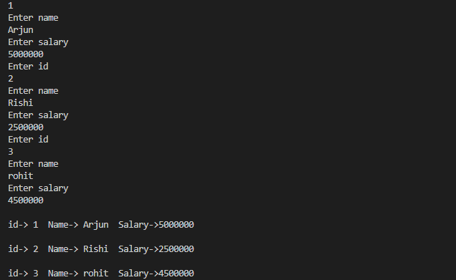

Q3)

#include<stdio.h>

#include<string.h>

typedef struct HR{

    int id;

    char name[30];

    int salary;

    int commision;

} HR;

void storeStrct(HR* h){

        printf("Enter id\n");

        scanf("%d", &h->id);

        printf("Enter name\n");

        scanf("%s", h->name);

        printf("Enter salary\n");

        scanf("%d", &h->salary);

        printf("Enter Commision\n");

        scanf("%d", &h->commision);

}

void printStrct(HR* h){

        printf("\nid-> %d  Name-> %s  Salary->%d Commision->%d\n", h->id, h->name, h->salary, h->commision);

}

int main(){

    struct HR h;

    storeStrct(&h);

    printStrct(&h);

    return 0;

}

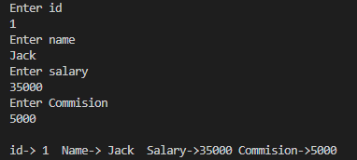

Q4)

#include<stdio.h>

#include<string.h>

typedef struct Admin{

    int id;

    char name[30];

    int salary;

    int allowance;

} Admin;

void storeStrct(Admin* admn){

        printf("Enter id\n");

        scanf("%d", &admn->id);

        printf("Enter name\n");

        scanf("%s", admn->name);

        printf("Enter salary\n");

        scanf("%d", &admn->salary);

        printf("Enter allowance\n");

        scanf("%d", &admn->allowance);

}

void printStrct(Admin* admn){

        printf("\nid-> %d  Name-> %s  Salary->%d Allowance->%d\n", admn->id, admn->name, admn->salary, admn->allowance);

}

int main(){

    struct Admin a1;

    storeStrct(&a1);

    printStrct(&a1);

    return 0;

}

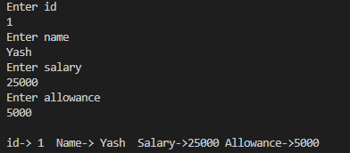

Q5)

#include<stdio.h>

#include<string.h>

typedef struct SalesManager{

    int id;

    char name[30];

    int salary;

    int incentive;

    int target;

} SalesManager;

void storeStrct(SalesManager* sm){

        printf("Enter id\n");

        scanf("%d", &sm->id);

        printf("Enter name\n");

        scanf("%s", sm->name);

        printf("Enter salary\n");

        scanf("%d", &sm->salary);

        printf("Enter Incentive\n");

        scanf("%d", &sm->incentive);

        printf("Enter Target\n");

        scanf("%d", &sm->target);

}

void printStrct(SalesManager* sm){

        printf("\nid-> %d  Name-> %s  Salary->%d Incentive->%d Target->%d\n", sm->id, sm->name, sm->salary, sm->incentive, sm->target);

}

int main(){

    struct SalesManager smr;

    storeStrct(&smr);

    printStrct(&smr);

    return 0;

}

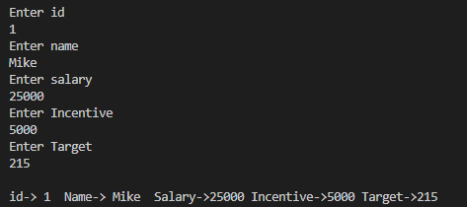

Q6)

#include <stdio.h>

#include <string.h>

typedef struct Date

{

    int date;

    int month;

    int year;

} Date;

void storeStrct(Date *dt)

{

    printf("Enter date\n");

    scanf("%d", &dt->date);

    printf("Enter month\n");

    scanf("%d", &dt->month);

    printf("Enter year\n");

    scanf("%d", &dt->year);

}

void printStrct(Date *dt)

{

    printf("\n%d/%d/%d\n", dt->date, dt->month, dt->year);

}

int main()

{

    struct Date dt;

    storeStrct(&dt);

    printStrct(&dt);

    return 0;

}

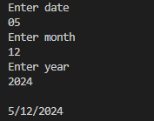

Q7)

#include<stdio.h>

#include<string.h>

typedef struct Time{

    int hr;

    int min;

    int sec;

} Time;

void storeStrct(Time* dt){

        printf("Enter Hour\n");

        scanf("%d", &dt->hr);

        printf("Enter Minutes\n");

        scanf("%d", &dt->min);

        printf("Enter Seconds\n");

        scanf("%d", &dt->sec);

}

void printStrct(Time* dt){

        printf("\nHr-> %d Minutes->%d Sec->%d\n", dt->hr, dt->min, dt->sec);

}

int main(){

    struct Time t;

    storeStrct(&t);

    printStrct(&t);

    return 0;

}

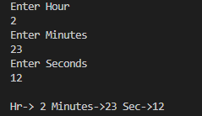

Q8)

#include <stdio.h>

#include <string.h>

typedef struct Distance

{

    float feet;

    float inch;

} Distance;

void storeStrct(Distance *dt)

{

    printf("Enter Feet\n");

    scanf("%f", &dt->feet);

    printf("Enter Inch\n");

    scanf("%f", &dt->inch);

}

void printStrct(Distance *dt)

{

    printf("\nLength is -> %.2f feets %.2f  inchs\n", dt->feet, dt->inch);

    printf("OR\n");

    printf("Length is -> %.2f' %.2f''", dt->feet, dt->inch);

}

int main()

{

    Distance t;

    storeStrct(&t);

    printStrct(&t);

    return 0;

}

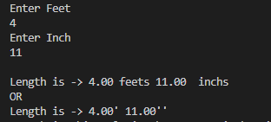

Q9)

#include<stdio.h>

#include<string.h>

typedef struct Complex{

    int real;

    int img;

} Complex;

void storeStrct(Complex* cmp){

        printf("Enter real num\n");

        scanf("%d", &cmp->real);

        printf("Enter imaginary num\n");

        scanf("%d", &cmp->img);

}

void printStrct(Complex* cmp){

        printf("\n%d + %di\n", cmp->real, cmp->img);

}

int main(){

    struct Complex cmp;

    storeStrct(&cmp);

    printStrct(&cmp);

    return 0;

}

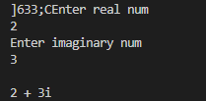

Q10)

#include<stdio.h>

#include<string.h>

typedef struct Product{

    int id;

    char name[30];

    int quantity;

    int price;

} Product;

void storeStrct(Product* prdt){

        printf("Enter product id\n");

        scanf("%d", &prdt->id);

        printf("Enter product name\n");

        scanf("%s", prdt->name);

        printf("Enter quantity\n");

        scanf("%d", &prdt->quantity);

        printf("Enter price\n");

        scanf("%d", &prdt->price);

}

void printStrct(Product* prdt){

        printf("\nid-> %d  Name-> %s  quantity->%d  price->%d totalAmount->%d rs.\n", prdt->id, prdt->name, prdt->quantity, prdt->price, prdt->quantity * prdt->price);

}

int main(){

    Product p;

    storeStrct(&p);

    printStrct(&p);

    return 0;

}

